LAUSD:

Year | Total LAUSD Enrollment | Total Population Los Angeles
2013-14 | 653,826 | 3,892,000
2014-15 | 646,683 | 3,923,000
2015-16 | 639,337 | 3,953,000
2016-17 | 633,621 | 3,981,000
2017-18 | 621,414 | 4,000,000

Elementary School Demographic Characteristics
for Years 2000 and 2010
 | 2000 |  |  | 2010
Variables | Mean | Min | Max | Mean | Min | Max
Enrollment | 859.04 | 194 | 2,538 | 606.15 | 136 | 1,681
Percent Asian | 0.068 | < 0.01 | 0.763 | 0.068 | < 0.01 | 0.641
Percent Black | 0.129 | < 0.01 | 0.944 | 0.098 | < 0.01 | 0.916
Percent Latino | 0.676 | 0.027 | 1.00 | 0.719 | 0.024 | 1.00
Percent White | 0.125 | < 0.01 | 0.847 | 0.106 | < 0.01 | 0.876

LAUSD maps out attendance area for most schools
Map for High Schools for 2004
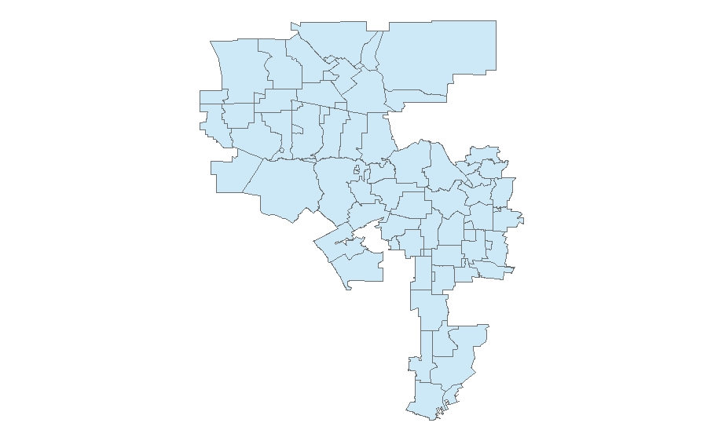
Data on ethnic distribution of schools 2000 and 2010

Compare proportion of different ethnic groups in individual schools to the ethnic distribution of attendance area
Calculate S_{j} - N_{j}
where S_{j} is the proportion the school (kinder through 4th grade) of ethnic group j. N_{j} is the proportion of the neighborhood’s children between five and nine years of age within ethnic group j.
Ethnic groups:
Non-Hispanic White, Hispanic, Black, Asian

Albion Elementary in 2010
 | Proportion of School (kinder thru 4th grade) | Proportion of Attendance Area's 5 to 9 years olds | Difference
Asian | 0.225 | 0.160 | 0.065
Black | 0.008 | 0.004 | 0.004
Latino | 0.751 | 0.822 | -0.071
White | 0.008 | 0.014 | -0.006

The Difference between School Population and Attendance
Area Age Cohort Populations by Ethnic Group
 | % of Attendance Area Cohort |  | Total Difference
Ethnic Group | Mean | Standard Deviation | Mean | Standard Deviation
Latino | -0.040 | 0.540 | -15.388 | 95.829
White | -0.506 | 0.524 | -47.835 | 77.932
Black | -0.286 | 1.047 | -14.785 | 41.339
Asian | -0.344 | 0.778 | -14.522 | 32.574

LAUSD Elementary Schools

