Economics studies how people make decisions regarding the use of scarce resources

Decisions could be individual (market) choices or collective (government) choices

It is assumed that every individual exchange is mutually satisfactory

For both parties in an exchange, the benefits of the transaction are at least as great as the costs

Many transactions generate environmental costs (pollution) that are largely unintended

Examples:

Environmental costs is framed largely as a decrease in benefits/well being of others not part of the transaction generating the cost

Course analyzes environmental costs of transactions

Evaluates ways to change incentives of market participants to limit excessive environmental damage

Carrots: “If you pollute your company’s name will be published in a website” or “If you pollute your taxes will be higher”

Sticks: “If you pollute we will throw you in jail”

Acts to alter incentives must be carefully considered:

- CAFE standards

Corporate average fuel economy standards (CAFE) were adopted in 1970’s
require automakers selling in the US to achieve minimum average miles per gallon for their fleet of cars
standards become more stringent over time

Part of reason for CAFE was relationship between mileage consumption and emissions

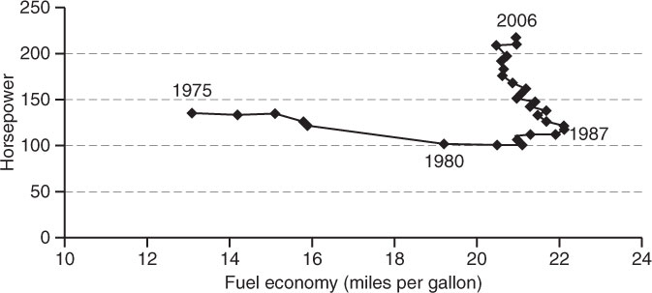

Separate lower standards for trucks; manufacturers switched to producing selling more trucks

Table on standards

- Waste Disposal

In 1994 the City of Marietta Georgia participated in an experiment in which fixed household fee for trash collection was replaced by per unit fees:

Garbage in Marietta collected twice a week

Disposal of solid waste (trash) is an environmental problem

The fixed monthly fee was done away and households had choice of two per unit pricing schemes: Bag or Subscription Can.

Trash Collection Program | Container Requirement | Monthly fee (per household) | Quantity Related Charges (per household)
Original (pre-1994) | None | $15 | None
Bag | 30 gallon plastic bag | $8 | $0.75 per bag collected
Subscription Can | 32 gallon trash can | $8 | $4 for first can subscribed per month  $3 for second can  $4 for each additional can
 | 20 gallon trash can | $8 | $3 per can; limit of one can

The $8 fixed fee charge in per unit programs paid for unlimited collection of recyclables, and large waste.

The can program reduced waste 20% (relative to original fixed fee program)

The bag system reduced waste by as much as 51%

