If market used to allocate good/services that produce external costs (pollution)

Society’s resources are used incorrectly
Social well-being not maximized

Actions to address externalities problem divided into:

- Regulations mandating that some transactions either do not take place or are altered (Command and Control)
- Programs that alter incentives of market participants (market-based solutions)

Command and Control

Environmental Protection Agency (EPA) exercises command and control by enforcing environmental standards

Ambient Standard
Government sets standard regarding quality of the environment
What is acceptable environmental quality?

Carbon Monoxide (CO)
A colorless, odorless gas emitted from burning fossil fuels
Reduces oxygen delivery to the body's organs
Can cause death

EPA CO standard:
1. 9 parts per million (ppm) averaged over 8 hour period
2. or 1 hour average over 35 ppm

Areas recording CO beyond either standard is out of compliance with EPA

http://www.arb.ca.gov/aqmis2/aqdselect.php?tab=daily

Area ambient standards are upheld by setting emissions standard for the major sources of the pollutant

Emissions Standard
Applies directly to sources of pollution
Limits the amount a source of pollution could emit

Most CO emissions come from autos

EPA limits the amount of CO emitted from motor vehicles per mile (depending on size and age of vehicle)

EPA Emissions Standard for CO: cars not allowed to go beyond approximately 4.2 grams of CO emissions per mile.

Emissions standards do not necessarily translate into specific ambient outcomes

For example, ambient standards for CO in an area can be violated although emissions standards for cars are satisfied
Local air quality depends on such factors as the volume of driving and weather conditions

Technology Standard

Specifies equipment or practices polluters must adopt

Cars must be equipped catalytic convertors
Coal plants required to use equipment to capture Sulfur Dioxide emissions

Example of AQMD regulations for Dry Cleaners

Compliance Cost of Emissions Standards

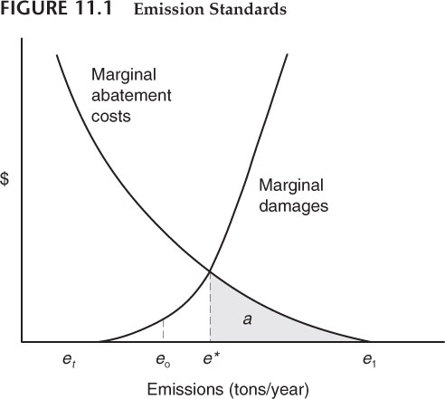
If emissions standard set to e* , are “a” abatement cost is the compliance cost of the standard

If emissions standard set at point where no social damage occurs, where would that be?

EPA general approach is to set emission standards at point where little adverse health effects results
This is in many cases below e*, the efficient amount

Many environmental laws use language implying that agency can use “reasonable” approaches
Implying cost considerations could be taken

Why do economists argue emission standard should be set at e*?
Would it be difficult for the EPA to find what e* is?

Standards and incentives
Standards normally set in which:
- Cost of non-compliance are large
- Incentive to do better than standard is low or non-existent

VW Violation

VW Conviction

VW Settlement

VW Senior Official Conviction

Review:
What is the difference between an emissions standard and an ambient standard?
Explain why emission standards should be set after ambient standards have been determined.
What is the difference between an emissions standard and a technology standard?
Explain why it might be easier to detect violations of technology standards than emissions standards.

