Government Income Support Programs
What is the difference between a means tested and non-means tested income support programs?
What is the definition of the poverty threshold?
Does the poverty threshold vary by family size?
Does the poverty threshold vary by family composition?
Are poverty thresholds generally used as the means test for federal poverty programs?
What is the difference between a cash transfer program and an in-kind program?
What is the largest means tested federal income support program?
What is the general definition of moral hazard?
The budget line below reveals the labor-leisure choices for a wage earner.
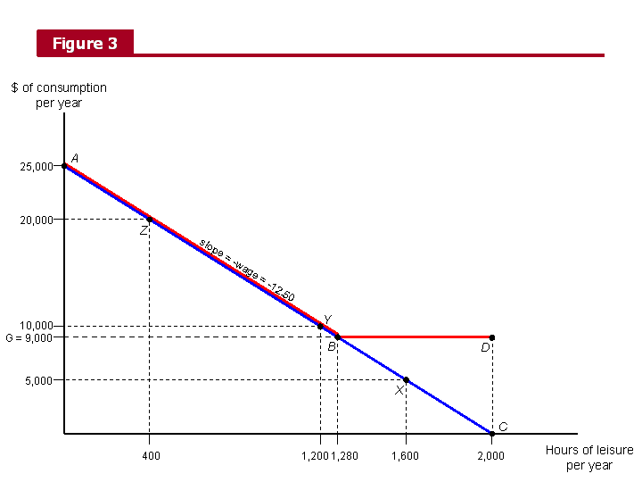
The wage earner moves along the budget line by changing hours worked or hourly wage earned?
If the wage earner generally favors consumption goods/services over leisure, she would be closer to point X or Z?
If a government program were implemented that guaranteed an income of $9000, explain why a wage earner previously at point X will likely move to point D?
In what way does the move X to D exemplify moral hazard?
If the guaranteed income program did not induce moral hazard for the wage earner at X, where would she have moved?
In the example why is the possible moral hazard costly for the program?
In what macroeconomic sense is the possible moral hazard costly?
Explain why the wage earner at Z is unlikely to move to D with the implementation of the program.
The budget line below reveals the labor-leisure choices for a wage earner. The guaranteed income is with 50% benefit reduction.
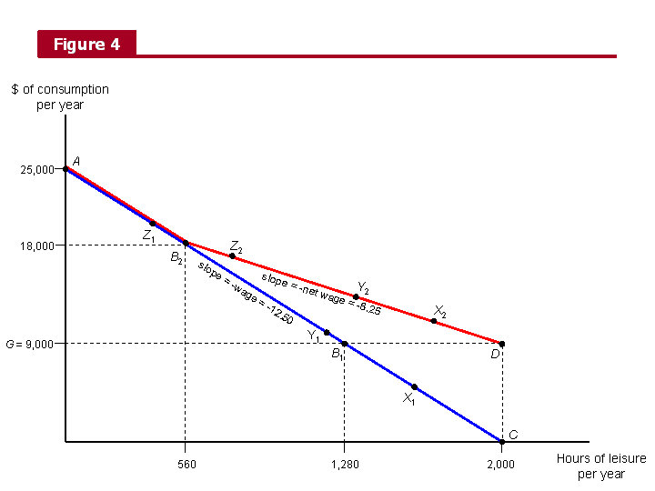
How does the 50% benefit reduction (as opposed to 100%) decrease the problem of wage earners at lower income levels dramatically decreasing their hours worked (decreasing the moral hazard problem)?
In what way does the 50% benefit reduction increase the range of income earners who could possibly decrease their work hours (increasing the moral hazard problem)?

What is the economic argument for offering cash (such as the EITC) versus in-kind benefits (such as SNAP) to recipients?

