Incentive Based Policies

Policies that internalize environmental costs to firms
Allows flexibility for firms adjusting its behavior

1. Pollution charges and subsidies
2. Pollution permits and trading

Pollution charge is typically a tax levied on firm per unit of emissions
Firm is not explicitly directed to achieve emission or technology standard

Goods produced with negative externalities are over-allocated;
“too much” of the good is produced

A marginal tax on transactions should decrease number of transactions made

Public policy problem is setting tax at point where policy goals achieved
-----------------------------
Shape of firm’s MAC
Reflects increasingly costly for firm to decrease emissions
If it could ignore costs, it would emit 10 tons/month
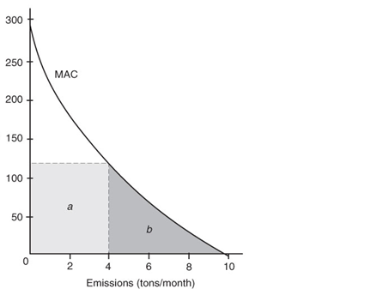

Suppose emissions tax of $120/ton/month is charged:

Tradeoff: As firm cuts emissions
A. Tax costs fall
B. Abatement costs rise

Firm will find emissions level minimizing tax plus abatement costs

Emissions h(tons/month) | Marginal Abatement Cost | Total Abatement Cost | Marginal Emissions tax | Total Tax Bill at $120/ton | Total Costs
10 | 0 | 0 |  | 1200 | 1200
9 | 15
8 | 30
7 | 50
6 | 70
5 | 95
4 | 115
3 | 150
2 | 185
1 | 230
0 | 290 | 1230 |  | 0 | 1230

Total cost minimized at 4 tons/month emissions

Why did the total costs to the firm fall continuously as it decreased emissions down to 4 tons?

Why do total costs begin to rise when the firm reduces emissions to less than 4 tons?

What rule should the firm use in the above example to minimize total costs (tax + abatement)?

At cost minimum, total tax of $480 represented by a; total abatement costs is $375 at b

What is cost of ignoring tax?
Cost of considering only the tax?

If 4 tons/month is emissions target, $120 tax is appropriate
Policy makers would have difficult time determining appropriate tax given a target emissions
Would not know shape of firms’ MAC curve

Firm should prefer a strict emission standard at 4 tons/month to the tax
Suffer only abatement cost of b

In above example:
Government revenue with emissions standard is 0
Government revenue with emissions tax is $480/month

What should government do with revenue raised by emissions taxes?

Swedish Nitrogen Charge

One of the dilemmas facing those who wish to use charges to control pollution is that the amounts of revenue extracted from those subject to the tax can be considerable; additional expense can produce significant political resistance to the policy. This resistance can be lowered if the revenue is rebated to those who pay it. But if all firms know they will received their money back, the economic incentive to limit emissions is lost. Is it possible to design a system of rebates that will promote political feasibility without undermining incentives?
The Swedish nitrogen charge was designed specifically to resolve this dilemma. Sweden’s nitrogen oxide emission charge was first imposed in 1992 on large energy sources. Some 120 heating plants and industrial facilities with about 180 boilers were subject to the tax.
The plan was intended from the beginning to have a significant incentive effect, not to raise revenue. Although the charge rate is high by international standards (thereby producing an effective economic incentive), the revenue from this tax is not retained by the government but rather is rebated to the emitting sources (thereby promoting acceptance of the policy of the regulated sources). It is the form of this rebate that makes this an interesting scheme. While the tax is collected on the basis of emission, it rebated on the basis of energy production. In effect this system rewards plants that emit little per unit of energy and penalizes plants that emit more per unit of energy, thereby proving incentives to reduce emissions per unit of energy produced.
As expected emissions per unit of energy produced fell rather dramatically. The Swedish ministry of the environment and natural resources has estimated that the benefits exceeded the cost by a factor of more than 3 to 1. Notice however that rebating the revenue means that this tax cannot produce a double dividend and provide no incentive to reduce energy consumption
Swedish tax and rebate scheme gives incentive to firms to decrease emissions per unit of output:
$\frac{nitrogen oxide emissions}{total energy produced}$ .
______________________________________________________
The local environmental agency charges emissions taxes:
Schedule of SCAQMD Fees
A. How much does a firm’s tax liability increase when it emits the 100th ton of sulfur dioxide in a year? Explain.
B. Calculate the firm’s total tax if it emits 100 tons of sulfur dioxide in a year.
Uniform taxation on firms may be inefficient

Assume firms emitting Nitrogen Oxide
Assume firms have same MAC but one firm located in urban center

MAC
MD of urban firm

MD of non-urban firm
t₂
t₁

emissions
Emissions from urban firm will effect more people; social damage will be greater
Efficient taxation would mean urban firm pays higher emissions tax
Even if abatement costs are equal across firms

Exercise on equal marginal principle

